APPLICATION FOR WITHDRAWAL OF ORIGINAL DOCUMENTS

Student’s Name:_________________________ Regn No: _______________________________
Prog: ____________Batch / Class: __________ Scholarship Availing/Availed: ________________
Mobile Number: _____________________ Status: Day Scholar/Hostelite: ____________________
Tick the name / specification of required documents:-

SSC: ___________ HSSC: ______________ BS:______________ MS: ______________

Maximum duration for issuance of above mentioned documents (30 days only) Deposit Date:_________

Purpose for withdrawal of Documents (call letter/any proof): ____________________________________

INSTRUCTIONS FOR STUDENTS (READ CAREFULLY). It is certified that :-
- I have attached an undertaking to this effect on stamp paper. I will be responsible for any loss/ damage. I will return the same on the above mentioned date. In case any extension in return date is needed, I will inform the Exam office through email (exam@seecs.edu.pk).
- I understand that in case I don’t return the documents on due date, I will NOT be allowed to sit in the ESE, my registration for subsequent semester will not be done (Result will be withheld in case of final year student) and will pay Rs.50/- as fine for each extra day after above mentioned deposit date.

Date: ________________ Student’s Signature. _________________

ACCOUNTS BRANCH, SEECS

Fee paid up to (Month /Semester):__________________________________________

Hostel Charges: ________________________ Fine (if any): ____________________

________________________
Accounts Officer, SEECS

DEPARTMENT, SEECS

Date: _____________ (HoD Concerned)._______________________

APPROVED / NOT APPROVED

_________________________
(Principal SEECS)
SEECS EXAM BRANCH

ACE (PG STUDENTS): _______________________

DEPUTY CONTROLLER (EXAM): _______________________________________

I have received my above mentioned documents in original: ______________________
Student’s Sign/Date
Updated on 28 Nov 2023 (Auth: Registrar Dte (NUST Min Office) eION no. 1426497 dated 28 Nov 2023)
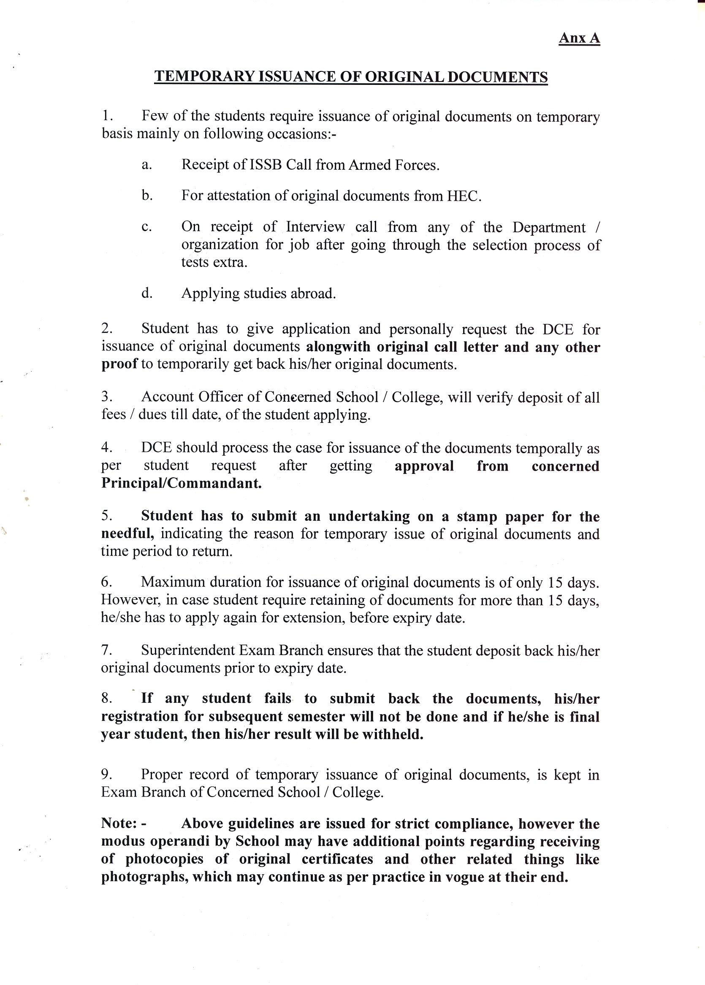
6. Maximum duration for issuance of original documents is of only 30 days. However, in case student require retaining of documents for more than one month, he/she has to apply again for extension, before expiry date.
UNDERTAKING

- I, (Name)_________________________, Registration No.________________, Program/Batch_________ have withdrawn original documents on ___________ (for maximum of 30 days) on temporary basis from Exam Branch, SEECS NUST for (Purpose) ______________________(attach original call letter/ any other proof).
- I hereby attach an undertaking to this effect on Stamp Paper declaring that :-
  - I will be responsible for any loss / damage to these documents.
  - I will return these documents on (Due Date):____________________.
  - In case any extension in above given return date is needed; I will inform SEECS Exam Branch through email before expiry of due date.
  - I also understand that in case I don’t return the documents on the given due date, I will not be allowed to sit in ESE, my registration for subsequent semester will not be done, result will be withheld (in case of final year student) and will pay a fine of Rs. 50/- for each extra day after due date.
- I have read and understood the instructions given above and sign it as correct.

Signature: _____________________________

Name of Student: ______________________
CNIC No: _____________________________
Contact No: ___________________________
Date: ________________________________

