Guidelines – Starting MS Thesis
Purpose:
In order to facilitate students during their thesis phase, such as submission of hardcopy thesis forms due to the requirement of hard form signatures (by the Supervisor/GEC members), the whole system has been automated using SEECS Project Management System (PMS)
(URL : www.pms.nust.edu.pk). This document familiarizes the students of the procedure for using PMS and different phases/activities they need to carry out during their research phase, hence facilitating the students in completing their thesis without any difficulty.

Responsible Stakeholders:
- Head of Departments (HoD)
- Exams Branch Staff
- Academic Coordination Branch
- MS Thesis Students
- Faculty (Thesis Advisor & GEC)
- PMS Admin

Starting Thesis/Eligibility
A student is eligible to start his/her research work after completing 9 credit hours with CGPA >= 3.0 and passing a Non-Credit course Research Methodology.
Once the student is eligible to start thesis, he may use the LMS credentials to log in to PMS (www.pms.nust.edu.pk) and start his/her thesis officially. However, if any student fails to log in to the PMS using LMS credentials, he/she may contact PMS Admin pmsadmin@seecs.edu.pk.
Creation of Project on PMS
For creating your Thesis/Project on PMS, coordinate with your potential Supervisor who will float the idea on PMS. Once the idea is floated, student will show his/her interest in the idea. Accordingly, the Supervisor will share the idea with the faculty members of particular domain who will show their interest to be part of GEC. When the GEC is formed, the student needs to fill in the desired details regarding his/her thesis on PMS.

Pre-Requisites for PMS
After logging in to PMS, the following screen appears:
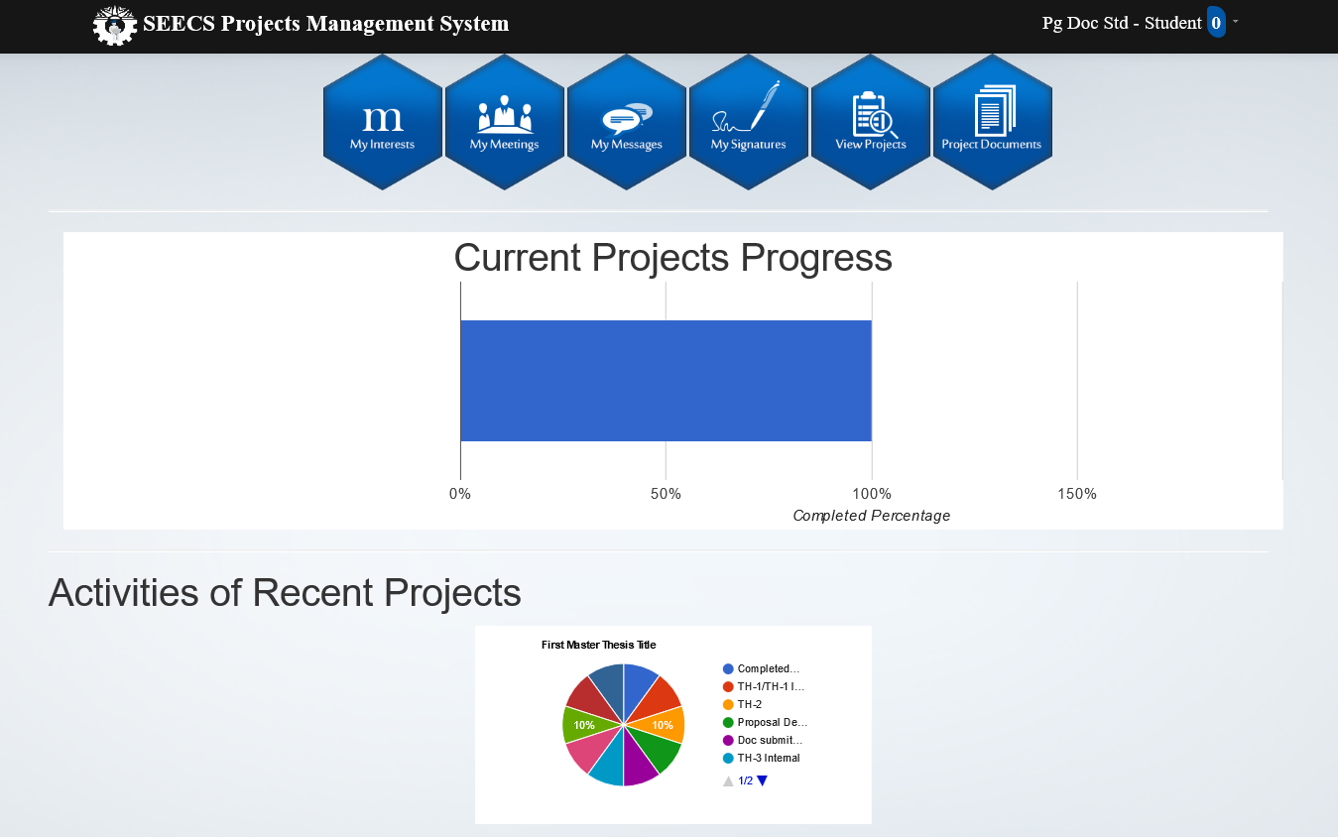

Go to my signatures tab and upload your signatures

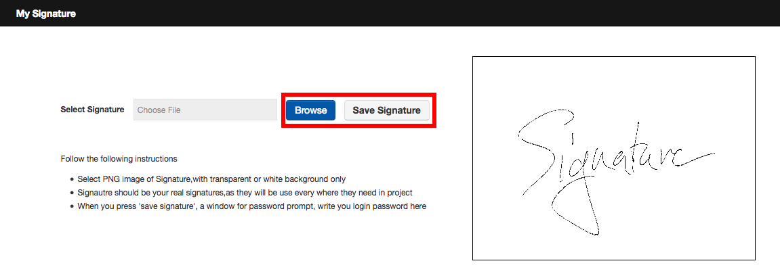
After uploading signatures, go to My Menu and add the courses you have undertaken during coursework with grades earned.
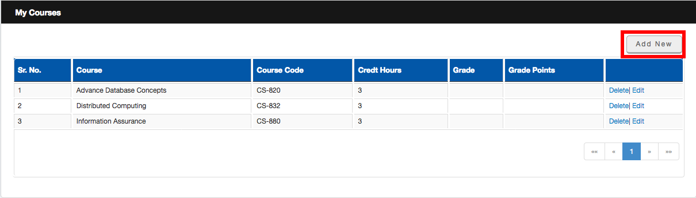
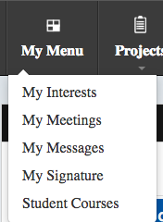

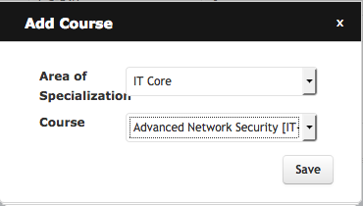

Once the courses are added, go to My Interests and float your Idea.
After the successful creation of Project, the next step is addition of Thesis Detail by following these steps
Go to View Projects -----> Open your Project ------ In Details Tab: Add Description and Abstract
(Please note that the Abstract should not be less than 3/4 of a page)
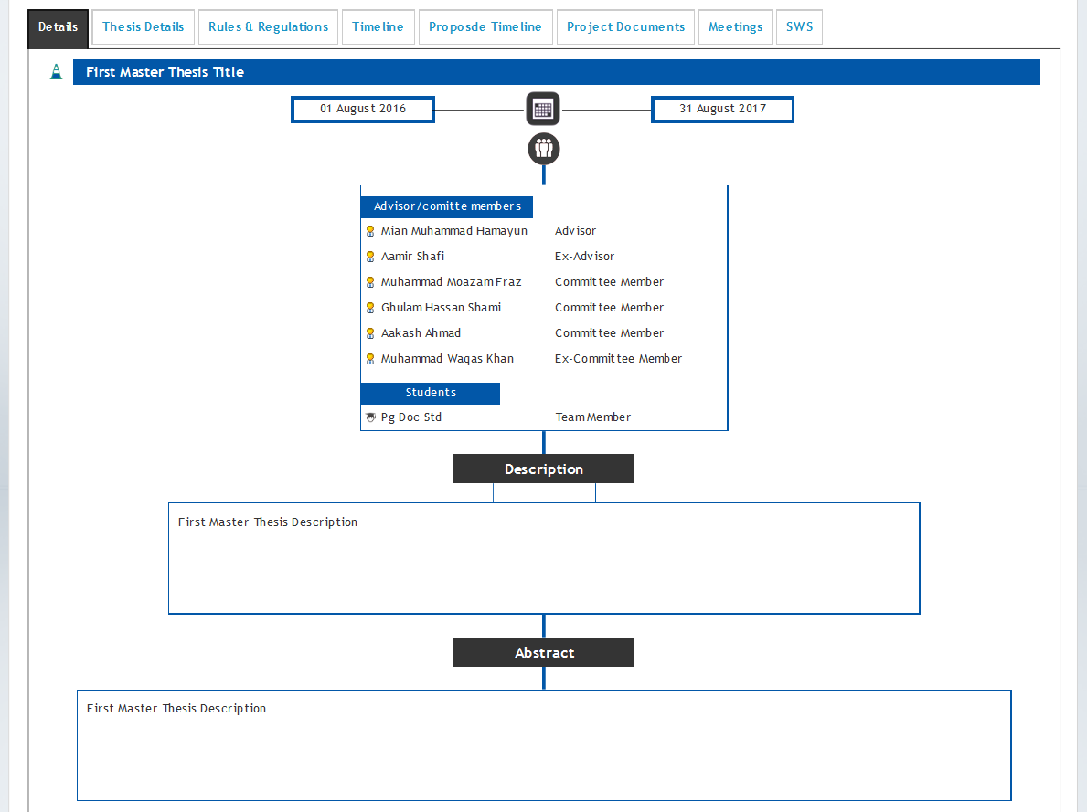

Then go to Thesis Details Tab and add the details
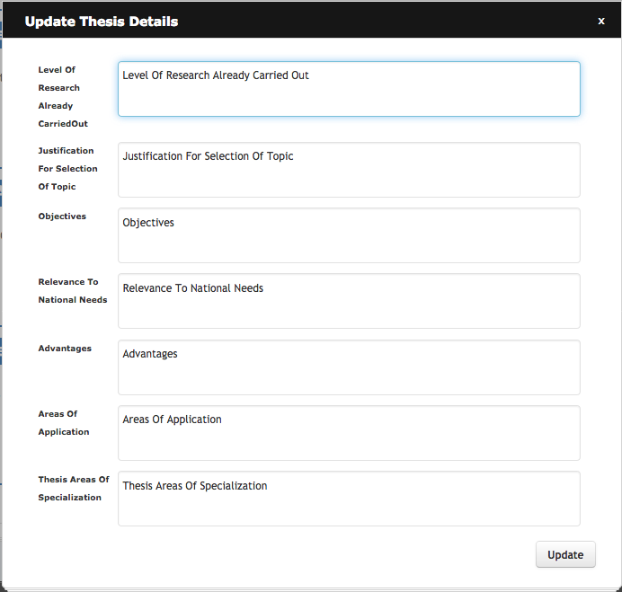

In Rules & Regulations Tab, Tick the boxes
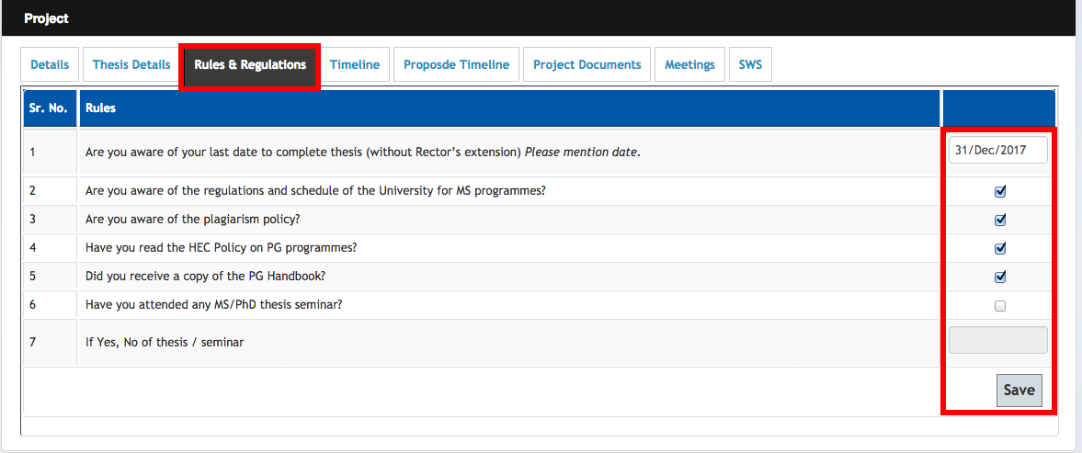

Go to Proposed Timeline Tab and add Timeline.
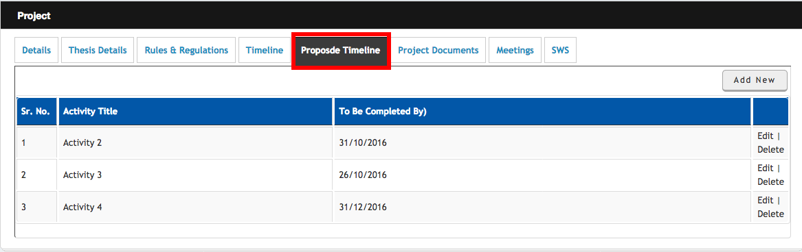

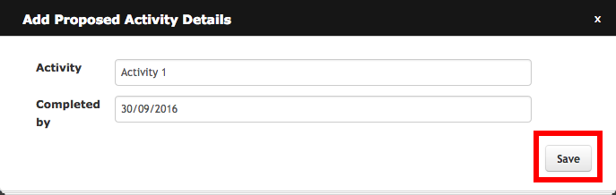

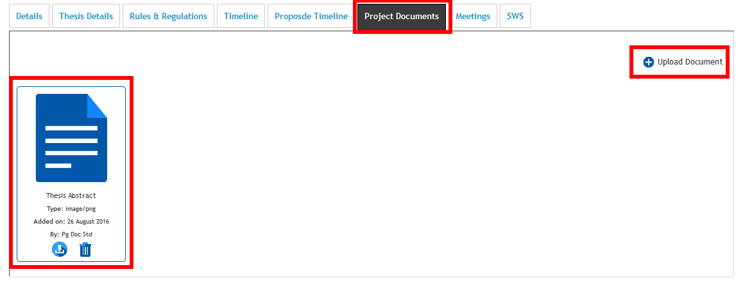
Go to Project Documents and upload documents
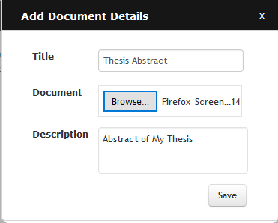

If you have successfully completed these steps, you are all set to start your thesis activities:
Starting Thesis Activities
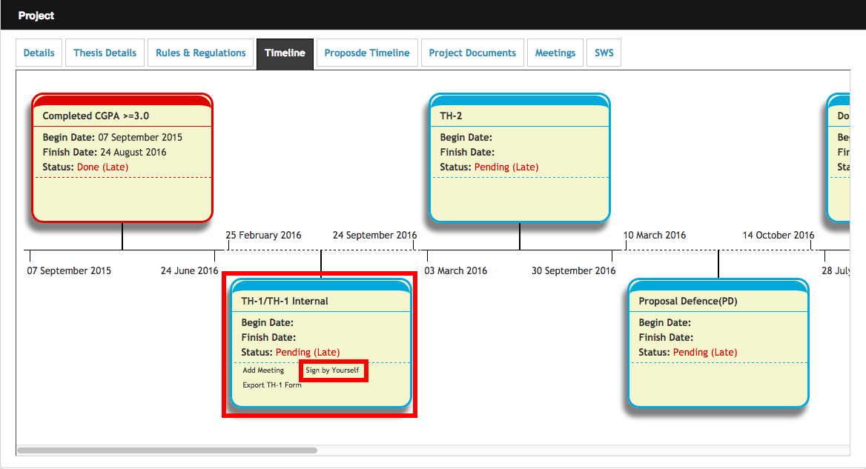
To initiate TH-1 activity, go to Timeline Tab and sign the activity by yourself

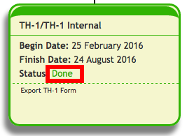
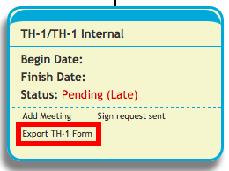
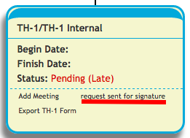

The activity will be completed after the signature of all the stakeholders, i.e. GEC, Exam & finally ACB. After its completion, you can initiate the next activity and all the remaining activities will be completed step by step using similar process.
Scheduling Proposal Defence
To schedule PD, initiate TH-2 activity and coordinate with your Advisor to fix a date for PD. After your Proposal Defence, spend some time to work on your Thesis Document/Write up.
Scheduling Inhouse Defence
Share the draft of your Thesis write-up with your GEC through email and initiate “DoC Submit to GEC” activity using Timeline Tab. After review of your document, the GEC will sign the activity on PMS making you eligible to appear in Inhouse Defence (IHD). To schedule IHD, initiate TH-3 Internal activity on PMS and coordinate your Advisor to schedule your IHD on any convenient date.
Preparing for Final Defence
After completion of Inhouse activity, initiate the TH-3 activity on PMS and wait for the signature of Advisor and Exam Branch. (Important: Exam branch will not sign your activity if there are any pending documents (academic or you need to submit to exams branch).
When the activity is signed by Exams Branch, submit hardcopy of the Thesis Write up/Book to ACB (Faculty Block) along with other forms (mentioned in diagram on next page) to schedule your Final Defence (FD will be arranged in minimum 02 x weeks time after submission of documents to ACB). Till TH-3 activity, student doesn’t need to submit hardcopy of any thesis form to any office.

Preparation of Thesis Documents/Forms
Student at TH-3 Stage

Student will compile the following duly Signed forms
- Plagiarism Report & Certificate
- Approval form
- Thesis acceptance certificate
- Scrutiny certificate
- Certificate of Originality
- Certificate for Submission of Thesis Book – Supervisor & Central Library

Annex ‘A’ will help the students for these forms

Hard Copy Printing & Binding
(Student Responsibility)
  - Guidelines for printing/binding & CD (Annex B).
  - Forms/documents to be attached in book
- Approval form
- Thesis Acceptance Certificate
- Certificate of Originality

Submission of following documents to ACB
    - 01x Hard copy of Thesis + CD
    - Approval form
    - Thesis Acceptance Certificate
    - Plagiarism Report & Certificate
    - Scrutiny Certificate
    - Certificate for Submission of Thesis Book – Supervisor & Central Library
Student can also send these to ACB through courier
When the FD activity is completed on PMS, student will initiate TH-4 form to complete the thesis process on PMS.
After signatures of GEC on TH-4 form, ACB will process the FD result and forward the duly signed result to SEECS Exams Branch. The process may take a week or two to complete. It is important to mention that TH-4 activity will be signed by ACB once the thesis result is forwarded to exams branch

Frequently Asked Questions
Expiry of Any Activity
It is very important for students to know that all activities on PMS remain available for signature of GEC for 48 hours only, from the time it is initiated. If the Advisor/GEC member does not sign the activity in stipulated time, the activity expires. Therefore, students need to coordinate with his/her GEC for endorsing activities before expiry.
Procedure for Extension
If any activity expires for the first time, Advisor can extend it using PMS (link appears below expired activity) but within one week and for maximum one week from the date of its expiry. For example,
Activity Expiry Date: 1st Dec 2021
Advisor’s extension remain available till: 8th Dec 2021
If Advisor extends activity on: 1st Dec 2021, the extension will work till 8th Dec 2021
If Advisor extends activity on: 7th Dec 2021, the extension still works till 8th Dec 2021

If the activity expires again, then the Senior HoD can be requested for 2nd extension using PMS (link appears below expired activity).

Changing Advisor/GEC
To change the Supervisor or any GEC, student need to submit duly signed TH-1A form available at SEECS website (https://seecs.nust.edu.pk/downloads/for-ms-thesis/) to Academic Coordination Branch. The form will be signed by both the GECs i.e. being deleted and added. However, if a GEC is not available at SEECS then the reason can be mentioned i.e. on long leave or left SEECS. The student will sign the form by him/herself, GEC and supervisor. Signatures of HoD/Principal are not mandatory for student. For the convenience of students, soft copy of the form with digital signatures is also acceptable.
Please note that the members of GECs cannot be increased or decreased once GEC is formulated. In that case, the idea will first be deleted on PMS to create a new one.
Changing Topic of the Thesis on PMS
The topic of the thesis can be edited by the Supervisor on PMS. However, if Supervisor faces any difficulty in changing the topic on PMS, he/she may send an email at manager.thesis@seecs.edu.pk , clearly mentioning the previous as well as revised topic, for the change on PMS.

Changing Thesis Idea
If a student wants to change his thesis idea, he/she may request supervisor to send an email to PMS admin (pmsadmin@seecs.edu.pk) with cc to Thesis Manager (manager.thesis@seecs.edu.pk). The email should request for deletion of the idea on PMS. The topic of thesis with student names must also be mentioned for deletion. Once the idea is deleted, the new idea will be floated on PMS.
Updation of Result on Qalam
Examination Branch, will compile the result (Thesis and coursework) to forward to PGP Dte for issuance of degree completion notification from the Registrar Dte (minimum time for issuance of notification by Registrar Dte is 02 months). At the same time, exams branch will update the result on Qalam. This process may take at least 15 working days to complete.
Issuance of Degree/Transcript
Students can apply for Degree or Transcript after the issuance of Degree completion notification by Registrar Directorate and application for this purpose will be submitted to Registrar Directorate, University Main Office.
If any student wants transcript before the issuance of Degree Completion Notification, then he can apply for the same with SEECS exams branch (Form available at Info Desk SEECS). However, the transcript issued in that case will contain the result/grades of course work only. Thesis result will not be displayed on transcript in such case.
Important: Clearance is a must for issuance of degree/transcript.
Procedure for Clearance
Clearance is done both on SEECS Support System as well as on Qalam.
Apply for SEECS internal clearance on Support System at http://support.seecs.edu.pk. In case of any issue in initiating clearance, contact ITS department (its@seecs.edu.pk)
Initiate Clearance on Qalam (www.qalam.nust.edu.pk). In case of any issue in initiating clearance on Qalam, contact CMS coordinator at cms@seecs.edu.pk.
Get yourself cleared from all the departments except SEECS Exams branch. When your internal clearance and Qalam Clearance is completed except from the Exam Branch/DCE), you need to submit your Student ID Card and Application for Refund of Security at SEECS exams branch.
The case for refund of the security fee will be processed when the clearance procedure is completed.

Annex A
The above mentioned forms can be obtained by following process.
Final Defense : Pre-Post Requirements
 | FD Prerequisites Activities | Required Actions & Processes
 |  | Online Action Req. by | Process
a. | 1x Plagiarism Report  (Single source should be less than or equal to 4% & overall should 18%)  For Plagiarism Report:  1x Plagiarism Certificate | Supervisor | - Use the original report generated through Turnitin  - Email report to Advisor for evaluation  - Advisor will sign the Plagiarism certificate digitally on PMS after in-house defense (TH-3) stage.  - Student will download the digitally signed certificate  - The report and certificate will not be attached in the Thesis Book. Rather, these will be submitted alongwith Book.
b. | Thesis Acceptance Certificate (On PMS) | Supervisor | - Advisor will sign the form on PMS after in-house defense.  - Digitally signed certificate will be downloaded  - Add one copy of the form in the Thesis Book (without signatures of HoD & Principal) and submit one copy of the form with Thesis Book  - ACB will get the signatures of HoD and Principal signature.
c. | Scrutiny Certificate (Annex C) | Engr. Nasir Mahmood | - For this certificate, email the thesis softcopy to Engr. Nasir Mahmood (nasir.mahmood@seecs.edu.pk). After reviewing the document as per guidelines (Annex “C” and return to student (by email).  - Student is required to get this certificate signed before thesis binding  - The form will not be a part of Thesis Book

d. | Certificate of Originality  (On PMS) | Student | - Student will download from PMS, sign and bind it into his/her thesis hardcopy.
e. | Approval Form  (On PMS) | Supervisor | - Supervisor & GEC members will sign the form on PMS
f. | Certificate of Submission of Thesis Book  (Annex D) | Supervisor  &  Central Library | - Submit 01 x hardcopy of the thesis write-up along with CD to Supervisor and get his/her signature on Form.  - Submit 01 x hardcopy of the thesis write-up along with CD to Central Library and get the sign/stamp on the form.  Note : For submission of hardcopies to Advisor and Central Library, you can signatures of S.HoD on Thesis Acceptance Certificate in place of Principal.

Annex B
Thesis Hardcopy Printing/Binding/CD
- It is the student responsibility to print, bind and courier the thesis to school (ACB) after vetting by his/her supervisor.
- Students can contact C2 printing shop owner, (detail given below), who is familiar with the NUST/SEECS thesis guidelines/style/template for the printing/binding issues.
Detail of Owner – C 2 Printing Shop
    - Name: Mr. Basit
    - Contact: 0301 5590520

- However, students are free to print/bind, while ensuring to follow the guidelines of school thesis format.

Requirement of CD Content

- A CD consists of following items
  - A soft copy of thesis
  - All above acceptance certificates.
  - (If applicable) Code with complete experimental setups

- Students may contact with C2 (Mr. Basit) for CD writing with following cost.

Annex C

NUST School of Electrical Engineering and Computer Sciences
A center of excellence for quality education and research
CERTIFICATE

Certified that the Scrutinizing Committee has reviewed the final documentation of Mr./Mrs/Miss._____________________________________Regn No.__________________
Student of_________________ Thesis title________________________________________
__________________________________________________________________________
and found satisfactory as per NUST’s standard format for Master Thesis.

President
Engr. Nasir Mahmood

Annex D
Certificate for Submission of Thesis Book – PG Students

It is certified that I have received 01x bound copy along with 01 x CD containing soft copy of thesis work submitted by following student: -

Name of Student: |  | ___________________________________________
Class: |  | ___________________________________________
Thesis Title: |  | ___________________________________________
Registration Number: |  | ___________________________________________
Name of Supervisor: |  | ___________________________________________

___________________________ |  | ___________________________
Supervisor |  | Central Library NUST

Annex E
The following guidelines to be followed for getting Scrutiny Certificate:

- Please put all the signed forms in a sequence as per the checklist (Annex F ):
- Chapter 1 starts at page 1.
- Before Chapter 1, all forms/documents are Roman numerals like (i), (ii), (iii).
- All page numbers should be in footnote at bottom and centered. You can use pdf editor to number the signed forms.
- Include subhead 6.1 Future Work in your Conclusion Chapter and write a paragraph under it.
- Please also send the filled scrutiny form (Annex C) along with the soft copy of your thesis documents for the signature of Engr. Nasir Mahmood (nasir.mahmood@seecs.edu.pk).
- Detailed guidelines for writing/formatting the thesis document have been provided in the Annex F
Important : You must get signed the Scrutiny certificate before binding of hard copies.

Annex F
(Formatting Guidelines - MS Thesis)
Cover and title page of the thesis
T1. | Topic of Research Thesis (As on PMS) and NUST logo
T2. | Student's name, Regn no. with degree title and induction year e.g.  Name : ABC  MSIT-2K20 : 00000123456
T3. | Supervisor's name
T4. | University and school's name is written e.g.  Department of Computing/Electrical Engineering  School of Electrical Engineering and Computer Science (SEECS)  National University of Sciences and Technology (NUST)
T5. | Date of completion/defense (only year and month) is mentioned e.g December 2021
Style and formatting issues
S1. | Consistent font (Times New Roman) is used throughout the thesis.
S2. | Page numbering is done appropriately.
S3. | Figures are readable and are aligned correctly.
S4. | Captions for tables and figures use consistent format and style.
S5. | Table of Contents/Figures/Tables follow proper indentation/styling.
S6. | Chapter name and numbering follows consistent style.
References/Bibliography
R1. | References are sorted on last name of authors (or in the order of citation in the text).
R2. | References follow consistent style such as ACM or IEEE-Tran.
R3. | Mandatory slots of references are filled correctly (such as Author, Title, Journal, Year).

Abstract (Note: This section covers only the abstract of the thesis)
A1. | There are no typing or grammatic mistakes in the abstract.
A2. | Problem statement is clearly mentioned.
A3. | Background to problem statement is also explained.
A4. | Startling statement (preferably a paragraph) about the thesis/hypothesis is present.
A5. | Implication of the startling statement is demonstrated briefly.
Results, Evaluation, and Conclusion
E1. | Research is validated either empirically or analytically (Note: This doesn’t cover quality of the results).
E2. | Outcome of this thesis is contrasted with other similar research initiatives.
E3. | Significance of this research is discussed in appropriate length.
Thesis Format/Sequence
S.No | Main Office NUST Format
1 | Title Page
2 | Thesis Acceptance Certificate
3 | Approval Page
4 | Dedication
5 | Certificate of Originality
6 | Acknowledgement
7 | Table of Contents
8 | List of Abbreviation
9 | List of Tables
10 | List of Figures
11 | Abstract
12 | Main Body
Checklist for Components in Main Body
S.No | Main NUST Format
1 | Introduction
2 | Literature Review
3 | Methodology
4 | Results
5 | Discussion
6 | Conclusion
7 | Recommendation
8 | Reference
9 | Appendices
10 | Index (Optional)

ACB Office Address for Courier Services:
Academic Coordination Branch
Office : A-113, Faculty Block,
School of Electrical Engg and Computer Science (SEECS)
NUST, H-12 Campus, H-12 Sector Islamabad.
Phone # 051-90852025

