Guidelines – Starting MS Thesis
Purpose:
In order to facilitate students during their thesis phase, such as submission of thesis forms due to the requirement of hard form signatures (by the Supervisor/GEC members), the whole system has been automated using SEECS Project Management System (PMS)
(URL : www.pms.nust.edu.pk). This document familiarizes the students of the procedure for using PMS and different phases/activities they need to carry out during their research phase, hence facilitating the students in completing their thesis without any difficulty.

Responsible Stakeholders:
- Head of Departments (HoD)
- Exams Branch Staff
- Academic Coordination Branch
- MS Thesis Students
- Faculty (Thesis Advisor & GEC)
- PMS Admin

Starting Thesis/Eligibility
A student is eligible to start his/her research work after completing 9 credit hours with CGPA >= 3.0 and passing a Non-Credit course Research Methodology.
Once the student is eligible to start thesis, he may use the LMS credentials to log in to PMS (www.pms.nust.edu.pk) and start his/her thesis officially. However, if any student fails to log in to the PMS using LMS credentials, he/she may contact PMS Admin pmsadmin@seecs.edu.pk.
Creation of Project on PMS
For creating your Thesis/Project on PMS, coordinate with your potential Supervisor who will float the idea on PMS. Once the idea is floated, student will show his/her interest in the idea. Accordingly, the Supervisor will share the idea with the faculty members of particular domain who will show their interest to be part of GEC. When the GEC is formed, the student needs to fill in the desired details regarding his/her thesis on PMS.

Pre-Requisites for PMS
After logging in to PMS, the following screen appears:
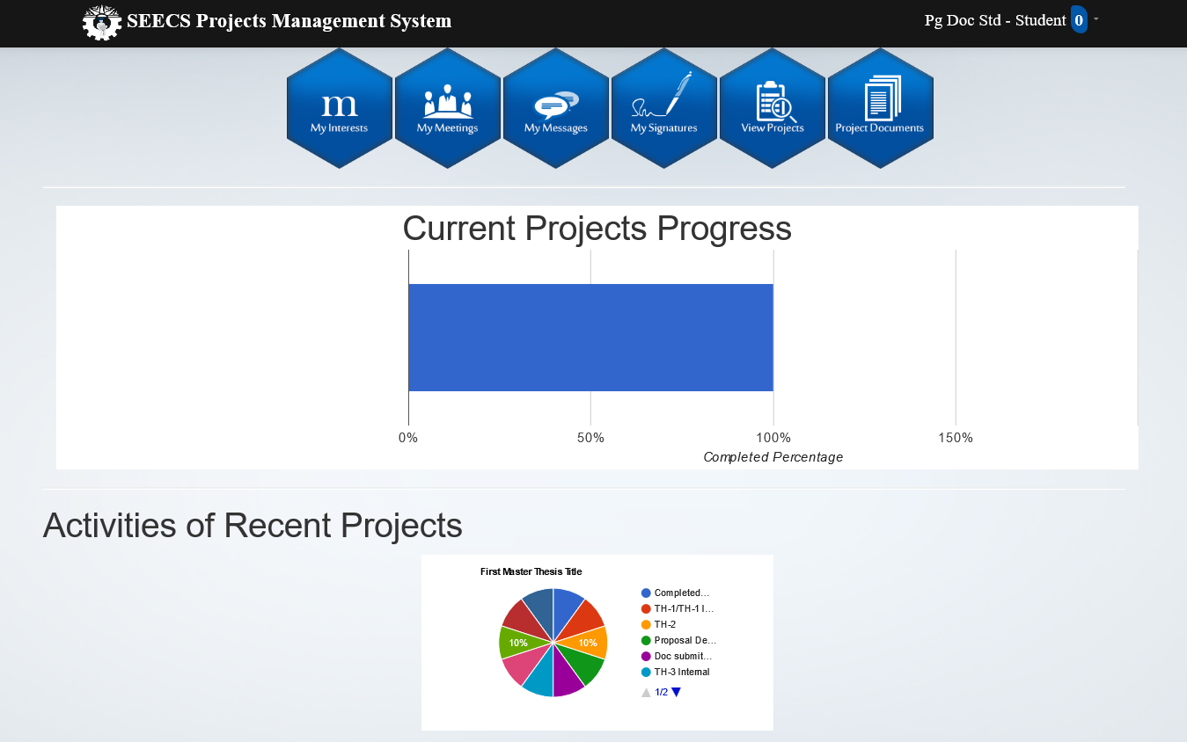

Go to my signatures tab and upload your signatures

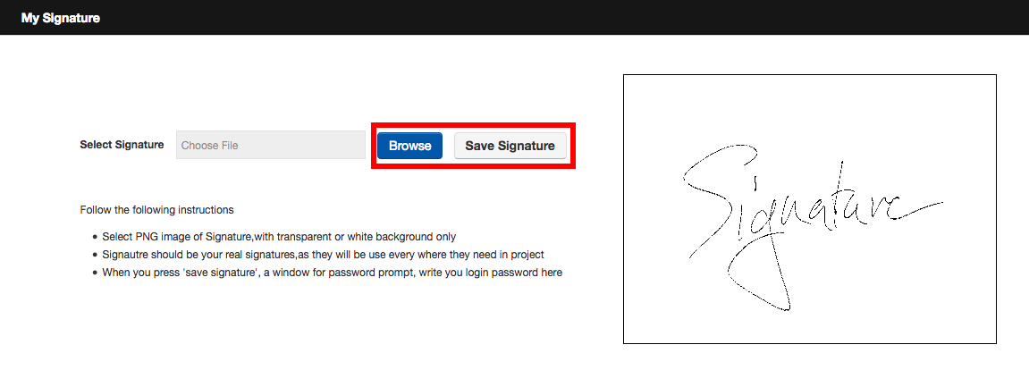
After uploading signatures, go to My Menu and add the courses you have undertaken during coursework with grades earned.
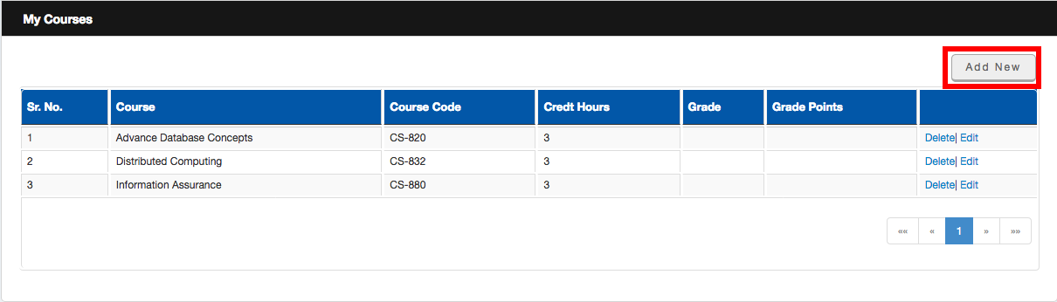
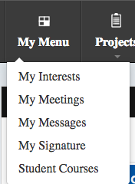

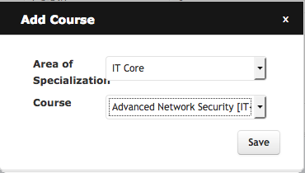

Once the courses are added, go to My Interests and float your Idea.
After the successful creation of Project, the next step is addition of Thesis Detail by following these steps
Go to View Projects -----> Open your Project ------ In Details Tab: Add Description and Abstract
(Please note that the Abstract should not be less than 3/4 of a page)
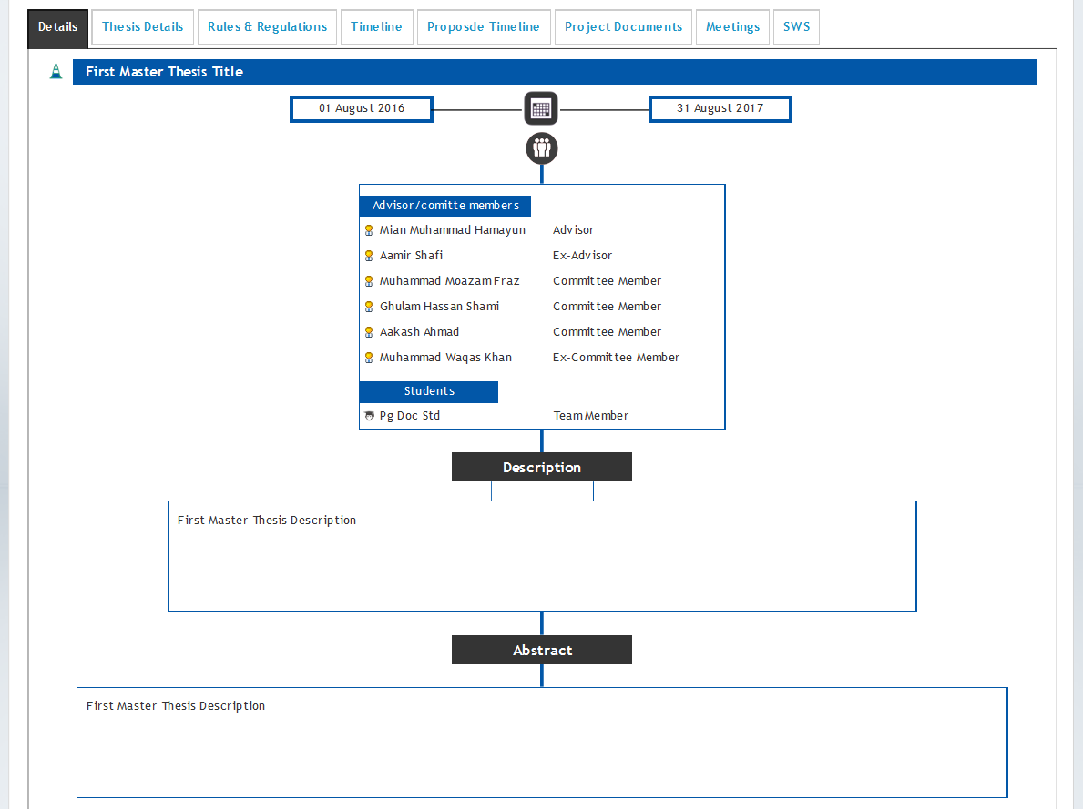

Then go to Thesis Details Tab and add the details
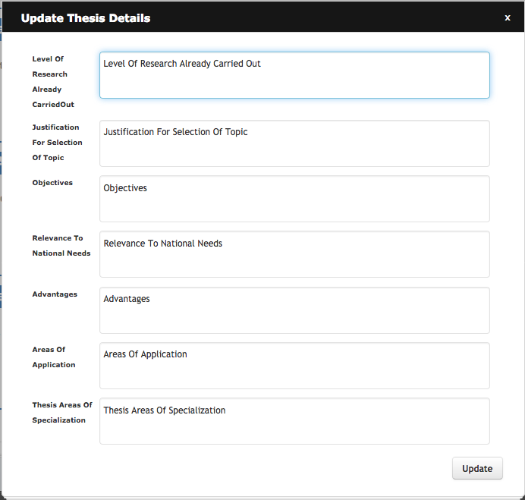

In Rules & Regulations Tab, Tick the boxes
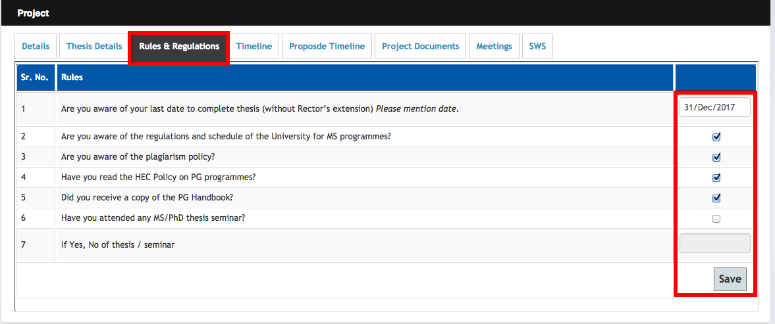

Go to Proposed Timeline Tab and add Timeline.
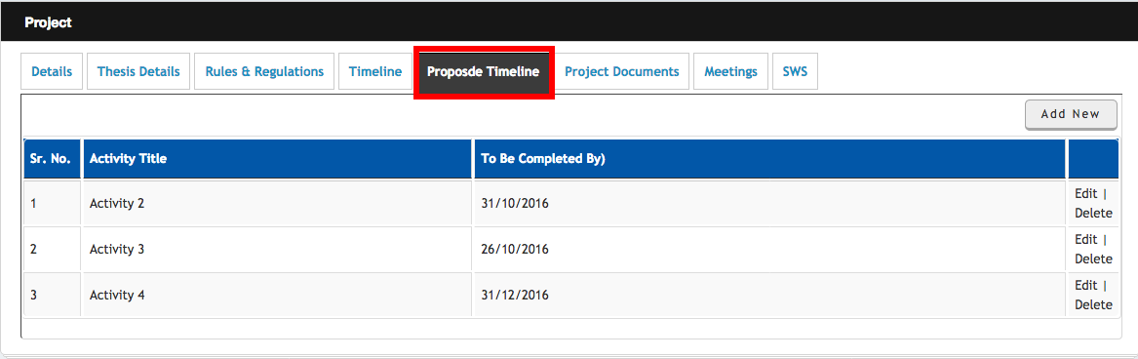

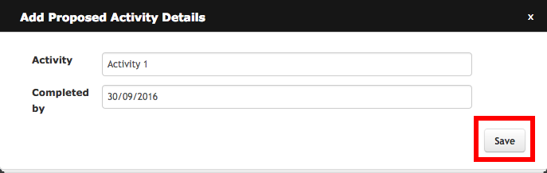

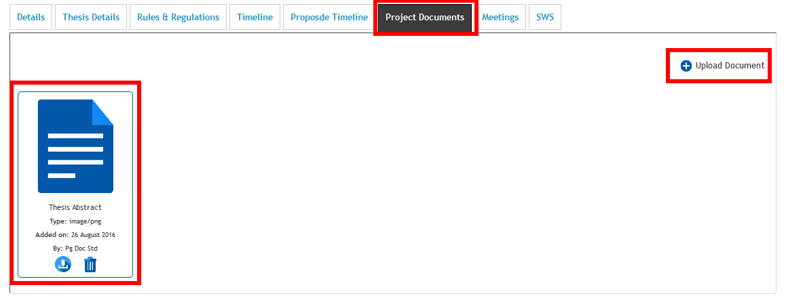
Go to Project Documents and upload documents
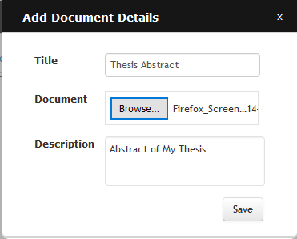

If you have successfully completed these steps, you are all set to start your thesis activities:
Starting Thesis Activities
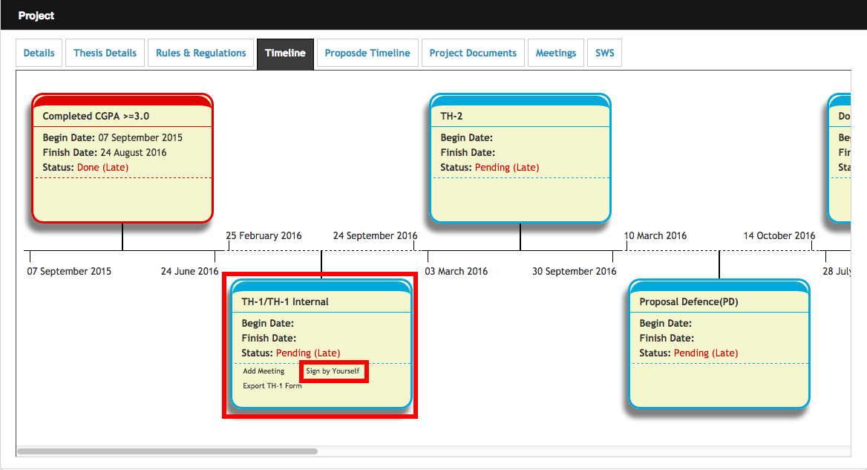
To initiate TH-1 activity, go to Timeline Tab and sign the activity by yourself

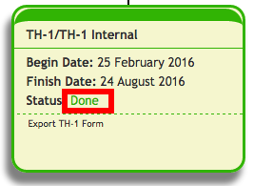
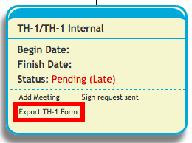
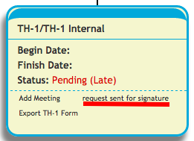

The activity will be completed after the signature of all the stakeholders, i.e. GEC, Exam & finally ACB. After its completion, you can initiate the next activity and all the remaining activities will be completed step by step using similar process. (Important: Exam branch will not sign your activity if there are any pending documents to be submitted by the student to exams branch)
Scheduling Proposal Defence
To schedule PD, initiate TH-2 activity and coordinate with your Advisor to fix a date for PD. After your Proposal Defence, spend some time to work on your Thesis Document/Write up.
Scheduling Inhouse Defence
Share the draft of your Thesis write-up with your GEC through email and initiate “DoC Submit to GEC” activity using Timeline Tab. After reviewing your document, the GEC will sign the activity on PMS making you eligible to appear in Inhouse Defence (IHD). To schedule IHD, initiate TH-3 Internal activity on PMS and coordinate your Advisor to schedule your IHD on any convenient date.
Preparing for Final Defence
After completion of Inhouse activity, initiate the TH-3 activity on PMS and wait for the signature of Advisor and Exam Branch. (Important: Exam branch will not sign your activity if there are any pending documents to be submitted by the student to exams branch)
When the activity is signed by the Exams Branch, submit softcopy (only) of your finalized Thesis Document to the Central Library to upload it online and get the form (Thesis Submission Certificate) available at Annex ‘D’ signed from Central Library. After submission of softcopy to Central Library, students are required to submit the following forms to ACB.
Student will complete the following duly Signed forms for submission to ACB
- Scrutiny certificate
- Approval form
- Certificate of Originality
- Plagiarism Report & Certificate
- Thesis acceptance Certificate
- Thesis Submission Certificate
- Students’ Particular Proforma

Annex ‘A’ will help the students for these forms

The Final Defence (FD will be scheduled in minimum 02 x weeks time after submission of documents to ACB).
(Important : Till TH-3 activity, student doesn’t need to submit hardcopy of any form to any office)
Post Final Defence Activities
When the FD activity is completed on PMS, student will initiate TH-4 form to complete the thesis process on PMS.
After signatures of GEC on TH-4 form, ACB will process the thesis result for signature of Supervisor, Associate Dean and finally the Principal. After the signatures, the signed result will be forwarded to SEECS Exams Branch for onward submission to University Main Office. The process may take a week or two to complete.
(Important : TH-4 activity will be signed by ACB once the thesis result is forwarded to exams branch, therefore be patient)

Frequently Asked Questions
Expiry of Any Activity
It is very important for students to know that all activities on PMS remain available for signature of GEC for 48 hours only, from the time it is initiated. If the Advisor/GEC member does not sign the activity in stipulated time, the activity expires. Therefore, students need to coordinate with respective GEC for endorsing activities before expiry.
Procedure for Extension
If any activity expires for the first time, Advisor can extend it using PMS (link appears below expired activity) but within one week and for maximum one week from the date of its expiry. For example,
Activity Expiry Date: 1st Dec 2021
Advisor’s extension remain available till: 8th Dec 2021
If Advisor extends activity on: 1st Dec 2021, the extension will work till 8th Dec 2021
If Advisor extends activity on: 7th Dec 2021, the extension still works till 8th Dec 2021

If the activity expires again, then the Senior HoD can be requested for 2nd extension using PMS (link appears below expired activity).

Changing Advisor/GEC
To change the Supervisor or any GEC, student need to submit duly signed TH-1A form available at SEECS website (https://seecs.nust.edu.pk/downloads/for-ms-thesis/) to Academic Coordination Branch. The form will be signed by both the GECs i.e. being deleted and added. However, if a GEC is not available at SEECS then the reason can be mentioned i.e. on long leave or left SEECS. The student will sign the form by him/herself, GEC and supervisor. Signatures of HoD/Principal are not mandatory for student. For the convenience of students, soft copy of the form with digital signatures is also acceptable.
Please note that the members of GECs on PMS cannot be increased or decreased once GEC is formulated. In that case, the idea will first be deleted on PMS to create a new one.
Changing Topic of the Thesis on PMS
The topic of the thesis can be edited by the Supervisor on PMS. However, if Supervisor faces any difficulty in changing the topic on PMS, the student may request his/her Supervisor to send an email at manager.thesis@seecs.edu.pk, clearly mentioning the previous as well as revised topic, for the change on PMS.

Changing Thesis Idea
If a student wants to change his thesis idea, he/she may request supervisor to send an email to PMS admin (pmsadmin@seecs.edu.pk) with cc to Thesis Manager (manager.thesis@seecs.edu.pk). The email should request for deletion of the idea on PMS. The topic of thesis with student names must also be mentioned for deletion. Once the idea is deleted, the new idea will be floated on PMS.
Updation of Result on Qalam
Examination Branch, will compile the result (Thesis and coursework) to forward to PGP Dte for issuance of degree completion notification from the Registrar Dte (minimum time for issuance of notification by Registrar Dte is 02 months). At the same time, exams branch will update the result on Qalam. This process may take at least 15 working days to complete.
Issuance of Degree/Transcript
Students can apply for Degree or Transcript after the issuance of Degree completion notification by Registrar Directorate and application for this purpose will be submitted to Registrar Directorate, University Main Office.
If any student wants transcript before the issuance of Degree Completion Notification, then he can apply for the same with SEECS exams branch (Form available at Info Desk SEECS). However, the transcript issued in that case will contain the result/grades of course work only. Thesis result will not be displayed on transcript in such case.
Important: Clearance is a must for issuance of degree/transcript.
Procedure for Clearance
Clearance is done both on SEECS Support System as well as on Qalam.
Apply for SEECS internal clearance on Support System at http://support.seecs.edu.pk. In case of any issue in initiating clearance, contact ITS department (its@seecs.edu.pk)
Initiate Clearance on Qalam (www.qalam.nust.edu.pk). In case of any issue in initiating clearance on Qalam, contact CMS coordinator at cms@seecs.edu.pk.
Get yourself cleared from all the departments except SEECS Exams branch. When your internal clearance and Qalam Clearance is completed except from the Exam Branch/DCE), you need to submit your Student ID Card and Application for Refund of Security at SEECS exams branch.
The case for refund of the security fee will be processed when the clearance procedure is completed.

Annex A
The Thesis Forms can be obtained as mentioned under:
Final Defense : Pre-Post Requirements
 | FD Prerequisites Activities | Required Actions & Processes
 |  | Action by | Process
 | Plagiarism Certificate | Student | - Digitally signed certificate will be downloadable from PMS after IHD.
a. | Plagiarism Report  (Single source should be less than or equal to 4% & overall should less than 19%) | Student | - Plagiarism Report will be generated by the Advisor on the Turnitin through his own account  - The report and certificate will be not be included in the Softcopy to be submitted to Central Library. Only the Hardcopy of the report will be provided to ACB.
b. | Thesis Acceptance Certificate (On PMS) | Student | - Digitally signed (only by Advisor) certificate will be downloadable from PMS after IHD.  - Student will submit the same form to ACB. After the FD, ACB will get the signatures of HoD and Principal on the form.
c. | Scrutiny Certificate (Sample at Annex B) | Advisor | - For this certificate, email the thesis softcopy and the filled scrutiny certificate to Advisor. After reviewing the document as per template available at the following link: https://www.overleaf.com/latex/templates/nust-ms-thesis-template/sqbgpxgvwgwx, the Advisor will return duly signed form to the student (by email).  - This form will not be a part of Thesis document to be submitted to Central Library.
d. | Certificate of Originality  (On PMS) | Student | - Student will download from PMS, sign and bind it into his/her thesis hardcopy.
e. | Approval Form  (On PMS) | Supervisor | - Supervisor & GEC members will sign the form on PMS

f. | Thesis Submission Certificate  (Annex C) | Supervisor/HoD  &  Central Library | - After your FD, submit Softcopy of the finalized thesis write-up to the Central Library and get signature/stamp on Form. The edit-able form is available at Annex C.
g. | Students’ Particulars Proforma  (Annex D) | Student | - This form will be submitted along with thesis write-up. Also attach Mark sheet of Matric with the certificate.

Annex B

NUST School of Electrical Engineering and Computer Sciences
A center of excellence for quality education and research
CERTIFICATE

Certified that the Scrutinizing Committee has reviewed the final documentation of Mr./Mrs/Miss._____________________________________Regn No.__________________
Student of_________________ Thesis title________________________________________
__________________________________________________________________________
and found satisfactory as per NUST’s standard format for Master Thesis.

Advisor

Thesis Submission Certificate
Annex C
(For SEECS Students)
Important Note: The tile should be written exactly as it is on PMS. No overwriting on form is acceptable. Please delete this text box before printing of form.

Certified that final soft copy (in pdf) of approved version of MS/M.Phil thesis titled ______________________________________________________________________________________________________________________________________________________________________________________________________________________________________________________written by Mr/Ms _____________________________________________________, Registration No _________________ , of MS____________________ program, has been submitted in NUST Central Library on ________________________, uploaded on D-Space and can be accessed at following link:
http://10.250.8.41:8080/xmlui/handle/123456789/____________

Signature & Stamp ________________________________________
Name of Supervisor _______________________________________
Date : ______________________

Signature (HoD) : _________________________________________
Date : ______________________

Signature (Chief Librarian) : _________________________________
Date : ______________________

Signature (Dy Controller of Exams): ___________________________
Date : ______________________
Annex D
Student’s Particulars - Certificate

It is certified that the under-mentioned detail is correct to the best of my knowledge and belief.

Regn No.
Name of Student
Father’s Name
Category
Scholarship Awarded | (Yes / No)
Gender
Date of Birth
Attach SSC Certificate | Please attach Matric Certificate with this form.  (Delete it before printing)

Dated: ___________ ___________________
(Signature of Student)

COUNTERSIGNED

(To be filled in by respective institute)

Dated: ___________ ______________________________
(Deputy Controller of Exam)

